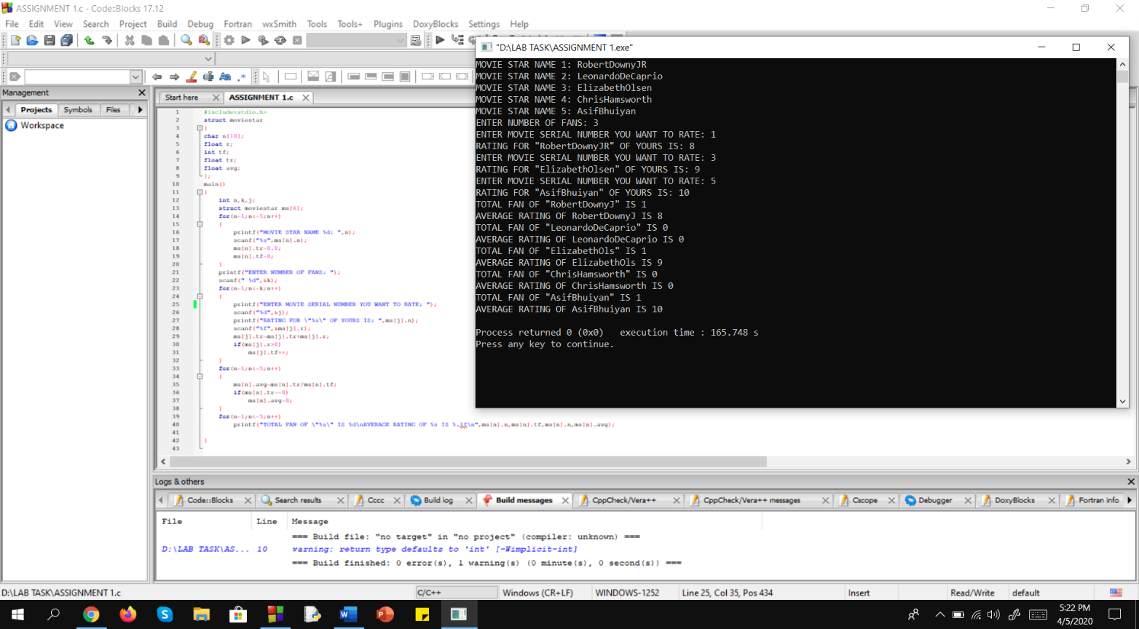**1.ASSIGNMENT NUMBER ONE.**

#include<stdio.h>

struct moviestar

{

char n[10];

float r;

int tf;

float tr;

float avg;

};

main()

{

int n,k,j;

struct moviestar ms[6];

for(n=1;n<=5;n++)

{

printf("MOVIE STAR NAME %d: ",n);

scanf("%s",ms[n].n);

ms[n].tr=0.0;

ms[n].tf=0;

}

printf("ENTER NUMBER OF FANS: ");

scanf(" %d",&k);

for(n=1;n<=k;n++)

{

printf("ENTER MOVIE SERIAL NUMBER YOU WANT TO RATE: ");

scanf("%d",&j);

printf("RATING FOR \"%s\" OF YOURS IS: ",ms[j].n);

scanf("%f",&ms[j].r);

ms[j].tr=ms[j].tr+ms[j].r;

if(ms[j].r>0)

ms[j].tf++;

}

for(n=1;n<=5;n++)

{

ms[n].avg=ms[n].tr/ms[n].tf;

if(ms[n].tr==0)

ms[n].avg=0;

}

for(n=1;n<=5;n++)

printf("TOTAL FAN OF \"%s\" IS %d\nAVERAGE RATING OF %s IS %.lf\n",ms[n].n,ms[n].tf,ms[n].n,ms[n].avg);

}